#### VMware IT

DCIM Reservations Manager

Version 0.1

April 3, 2017

#### Presented by: Phil Pennington

Contents

Reservations Management Scenarios 3

Overview 3

New Asset Deployment 5

Supporting NLyte Feature-Areas 5

New Reservation Ticket Prerequisites 6

Create Asset Reservation 6

Step 1, Locate the NLyte Material Type 7

Step 2, Create an Instance of the Selected Material Type 10

Step 3, Configure the New Asset Record 12

Step 4, Place the Reserved Asset into the Target Cabinet Location 15

Step 5, Place the Reserved Asset into the Target Rack Unit Position 18

Step 6, Update the ServiceNow Ticket with the Asset Reservation, PSC Approved Stamp 22

Move Asset Request 22

Move Ticket Prerequisites 22

Step 1, Locate the Existing NLyte Asset Record 23

Step 2, Record the Request Ticket Number within the PR Number field 24

Step 3, Place the Asset in a Planned Move State 25

Step 4, Mount the “Planned Moving” Asset Record into the Target Cabinet Location 26

Step 5, Forward the Work Order to the Operations Team for Fulfillment 31

Step 6, The Operations Team Completes the Move Request 33

Decommission Asset Request 33

Decommission Ticket Prerequisites 33

Step 1, Locate the Existing NLyte Asset Record 34

Step 2, Record the Decommissioning Ticket Number 35

Step 3, Place the Asset in a Planned Decommissioning State 36

Step 4, Set the Decommissioned Asset Location 37

Step 5, Forward the Work Order to the Operations Team for Fulfillment 38

Step 6, The Operations Team Completes the Decommission Request 40

# Reservations Management Scenarios

This checklist document addresses the usage scenarios associated with the Data Center Infrastructure Management (DCIM) **Reservations Manager** role.

## Overview

The following illustration highlights the primary feature areas of a DCIM solution and suggests user-roles with responsibilities within each area. IT Operational business activities map to a combination of People, Processes, and Tools. DCIM tools support business objectives by enabling Roles definitions, corresponding Workflows, and Automation of tasks. The **Reservations Manager** role possesses responsibilities in each DCIM functional-area.

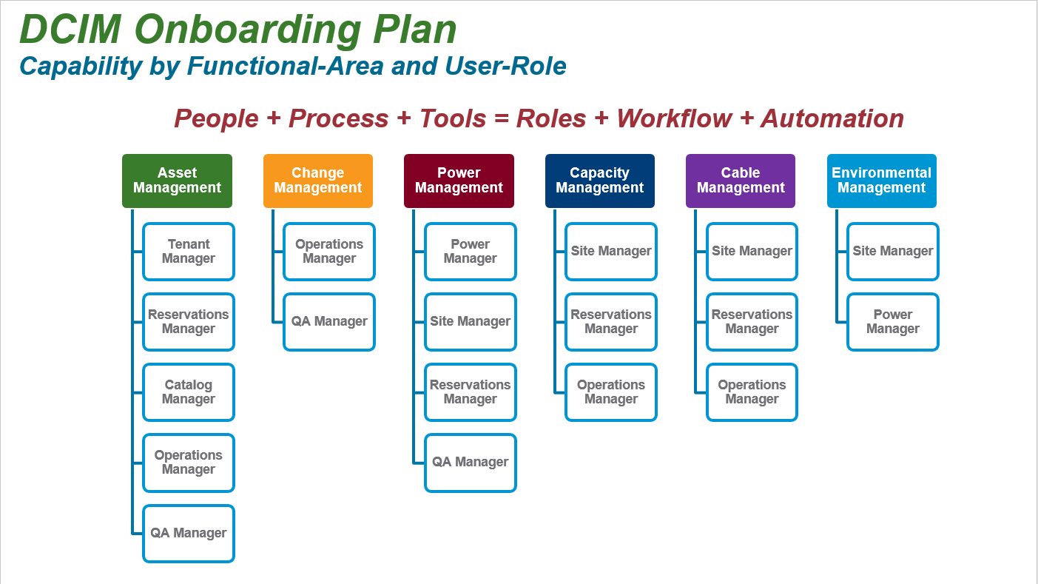

The following illustration suggests several logical use-cases associated with DCIM user-roles. Note that this isn’t a completing listing, but rather a starting-point for definition of those roles and use-cases matching our organizational business requirements. Ideally, DCIM tools enable these use-cases with only minor customizations.

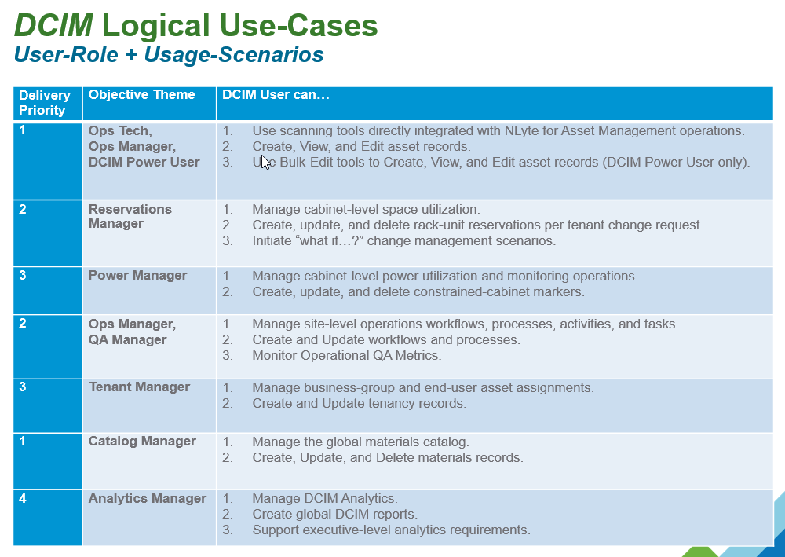

Note that the **Reservations Manager** role is primarily responsible for management of cabinet-level space utilization and **Change Management**.

In many cases, a Change Request will entail necessary combinations of activities and tasks. For example, a new deployment request may require first decommissioning or moving existing equipment to make room for the newly purchased assets. This document focuses only upon the following key activities utilizing the NLyte DCIM tools for reservations management tasks.

* Given a New Deployment ticket, create corresponding cabinet rack unit (RU) reservations for the new equipment specified.
* Given a Move ticket, place corresponding asset records into a Planned Move state and complete the move upon necessary Tenancy, and Operations workflows.
* Given a Decommission ticket, place corresponding asset records into a Planned Decommission state and complete decommissioning upon necessary Logistics, Finance, Tenancy, and Operations workflows.

## New Asset Deployment

The Reservations Manager must consider several contributing and dependency factors to accomplish a deployment change request including:

* Adequate Cabinet Size and Location (e.g. available contiguous Rack Units)
* Adequate Cabinet Power (e.g. capacity versus threshold, power-distribution capacity)
* Device Power Requirements (e.g. redundancy)
* Network Requirements (e.g. ports, wire-maps, V-Lans, logical and physical topology)
* Device Configuration Requirements (e.g. hostname policies)
* Cost Center and Tenancy (e.g. Owner, User, Business Group, Support Group)
* DCIM Catalog Material (e.g. existing model type, new custom model type)

### Supporting NLyte Feature-Areas

| Task | NLyte Feature Area Options | Notes |
| --- | --- | --- |
| Identify Available Rack Unit (RU) Space | 1. Use the “Cabinet Free Space” overlay report within the Floor Planner. 2. Use the “Multi-Tenancy, Cabinet Available U” report within the Analytics module. 3. Use the “IT, Cabinet Capacity” report within the Analytics module. 4. Use the Predict Module. | 1. A custom Site Capacity report is advantageous. 2. A custom Cabinet Power & Space Capacity report is advantageous. |
| Determine Available Cabinet Power | 1. Use the “Real-Time Power (kW)” overlay report within the Floor Planner. 2. Use the “Heat Gauge” within the Cabinet Planner. 3. Use the “IT, Real-Time Power Cabinet Capacity” report within the Analytics module. | 1. A custom Cabinet Power & Space Capacity report is advantageous. |
| Determine Available Power Distribution Connections | 1. Use the Cabinet Planner to determine available Power-Strips. 2. Use the Predict Module. | This NLyte feature-area requires data-import using the Power Bulk-Data Migration tool. |
| Assess Available Network Resources (Ports, VLans, etc) | 1. Use the Predict Module. 2. Use the Network Connectivity sub-report within the “Real-Time Power Cabinet Capacity” report within the Analytics module. | This NLyte feature-area requires data-import using the Network Bulk-Data Migration tool. |
| Assess Device Configuration Parameters | 1. Use the Asset Views page to input and edit configuration parameters. 2. Use the Bulk Data Migration tool to input and edit configuration parameters. | 1. The NLyte Audit Tool enables asset record editing from mobile devices with scan-tool integration. 2. The NLyte Goods Receiving module enables new asset record editing from mobile devices with scan-tool integration. |
| Establish Asset Tenancy and Support Groups | 1. Use the Asset Views page to edit business group and support group mappings. 2. Use the Business Group and Support Group record pages to create or edit groups. 3. Use the Bulk Data Migration tool to create and edit asset to BG and SG mappings. | The following mappings may be accomplished:   * Asset to Business Group * Asset to Support Group * Accounts to BG and SG |
| Assess Availability of Materials Catalog Types | 1. Use the Materials Catalog to find, create, and edit catalog records. 2. Use the BDM tool to create custom catalog entries. | Only the Global Catalog Manager should be able to create custom catalog entries. |

### New Reservation Ticket Prerequisites

The Reservations Manager should receive a “Power, Space, and Cooling” (PSC) pre-procurement approval subtask within the context of any operations change request (perhaps originating from a ServiceNow workflow). The following deployment attributes are minimally required for adequate PSC evaluation.

* Requested Asset Item Inventory
* Material Catalog model identification per deployment item
* Asset RU sizes
* Tenant Cost Center
* Tenant Owner and User Names
* ServiceNow Ticket Number (i.e. NLyte PR Number)
* Cable Management details (i.e. logical and physical network topology details)
* Any non-standard cabinet mounting details (e.g. shelfs)
* Any non-standard power connectivity details.
* Asset hostnames

An approved reservation request should result in a ticket update stamp with the following minimal detail list.

* PSC Approved Statement
* Per Item Cabinet Name and Rack Unit assigned location
* Detailed approval prerequisite statements (e.g. prior asset move or decommissioning dependencies)

## Create Asset Reservation

For example, assume the following simple PSC approval request details:

* Itemized inventory includes single server; a Dell R730 model.
* Tenant Cost Center = TESTCC123
* Tenant Owner and User = John Doe
* ServiceNow Ticket Number = RITM00777777
* Cable Management requirements = single GigE copper cable to the Top-of-Rack network switch
* Hostname = TESTSVR001

### Step 1, Locate the NLyte Material Type

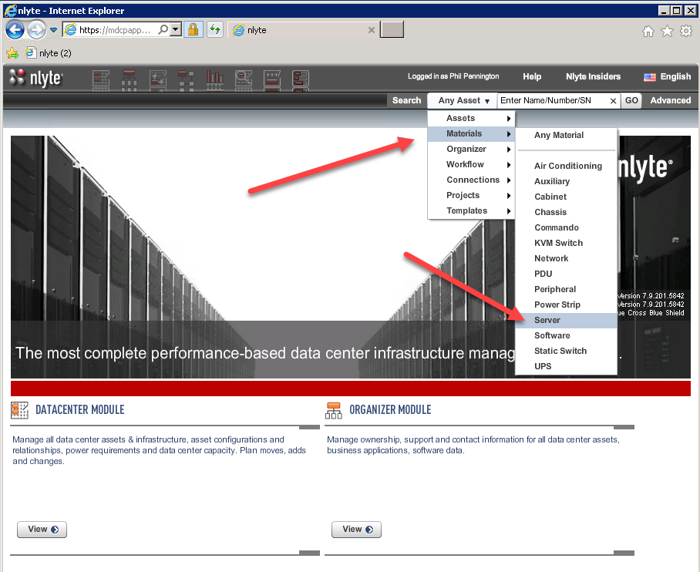

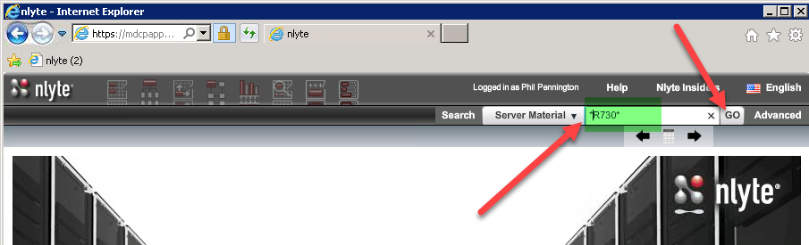

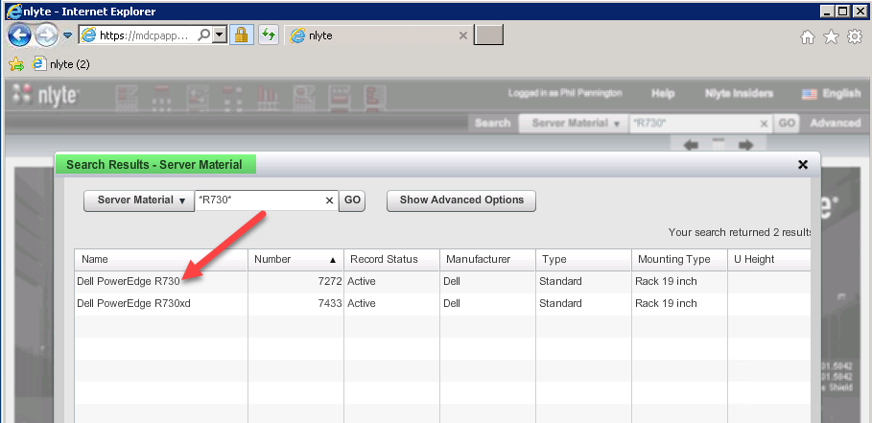

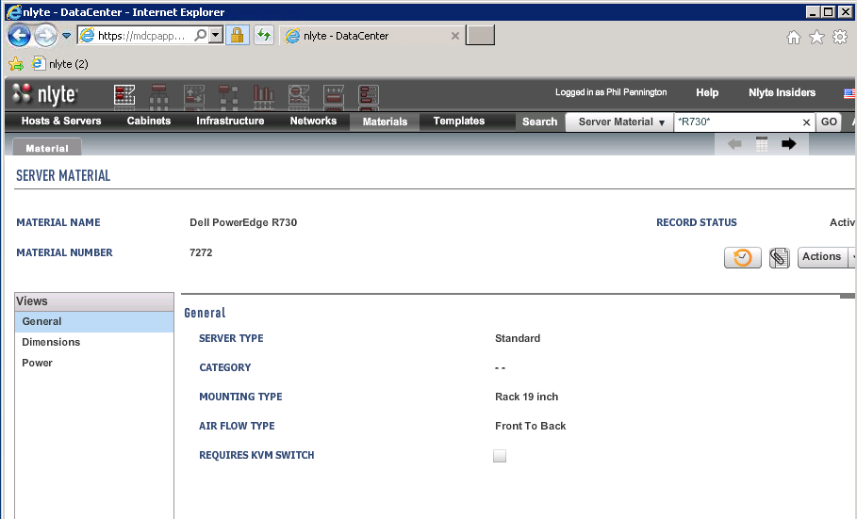

### Step 2, Create an Instance of the Selected Material Type

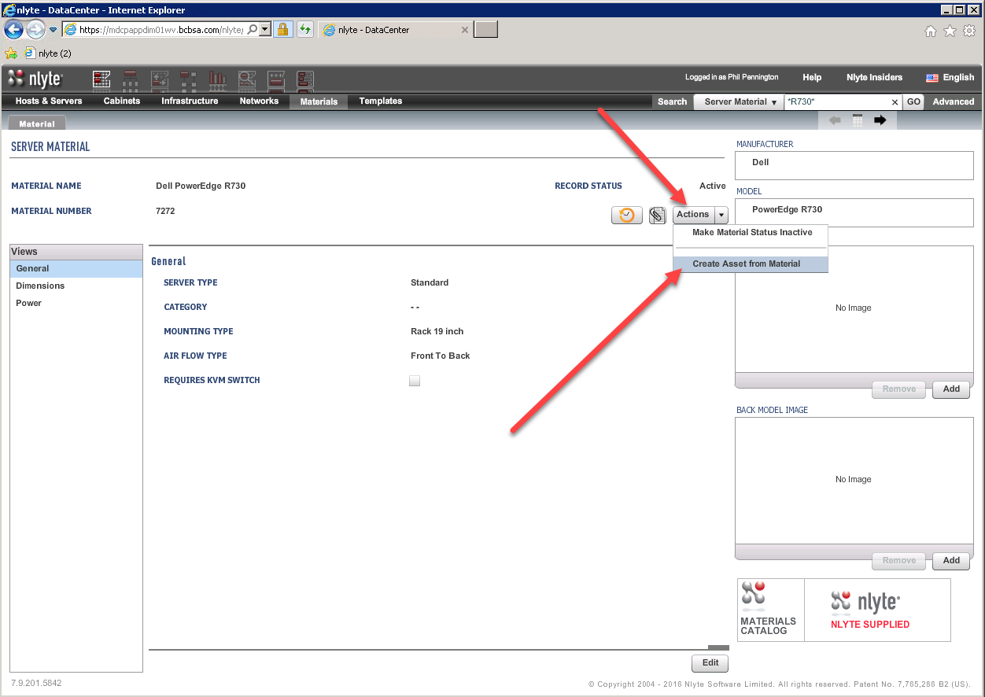

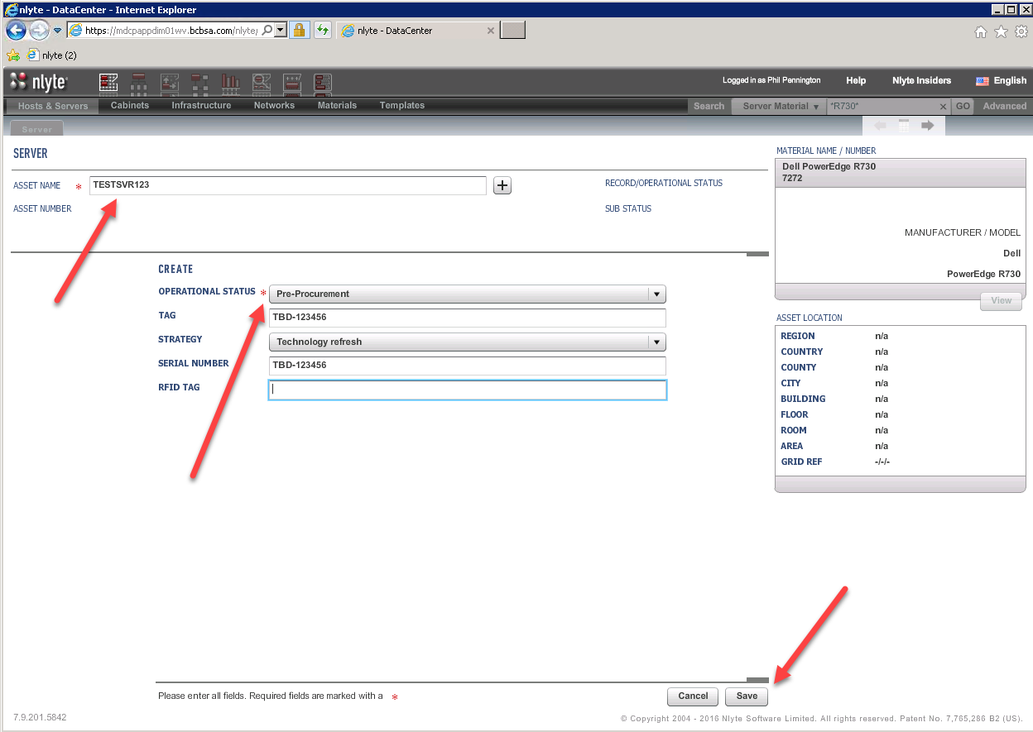

### Step 3, Configure the New Asset Record

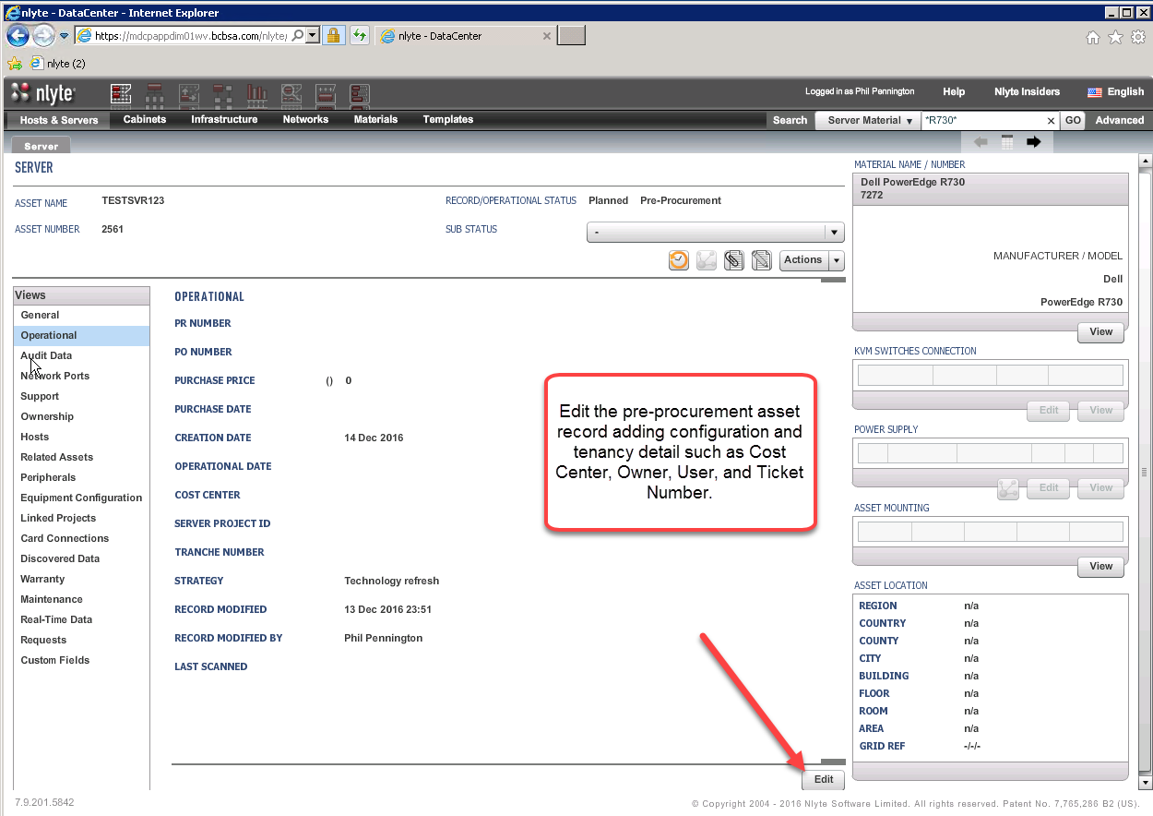

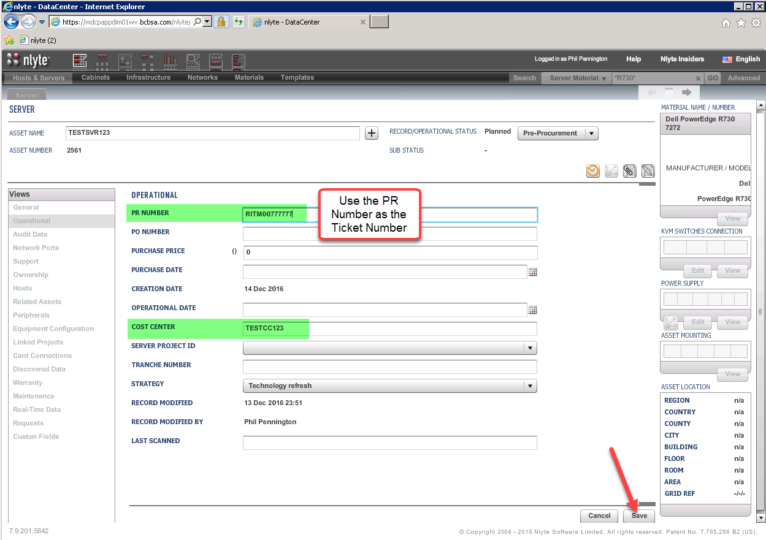

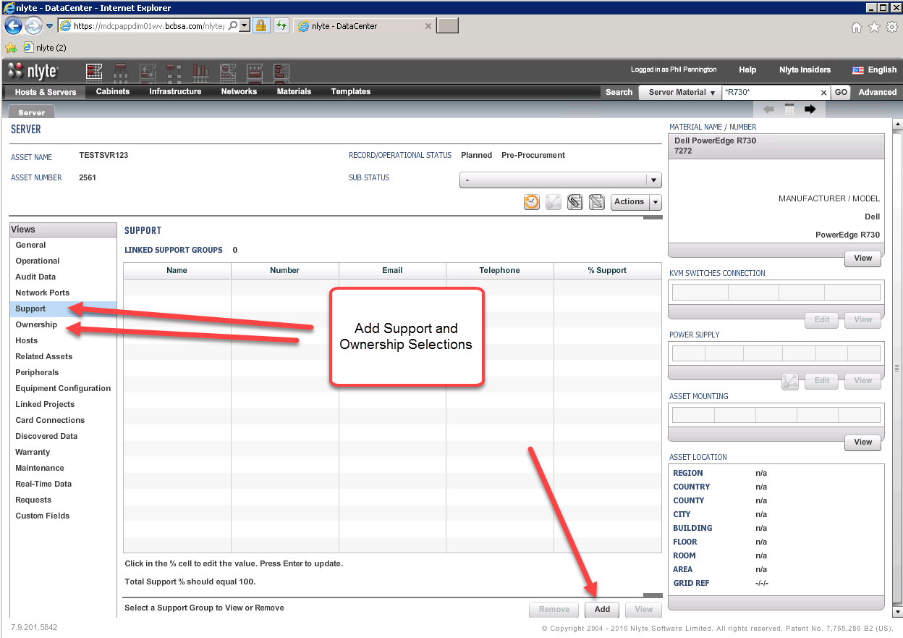

### Step 4, Place the Reserved Asset into the Target Cabinet Location

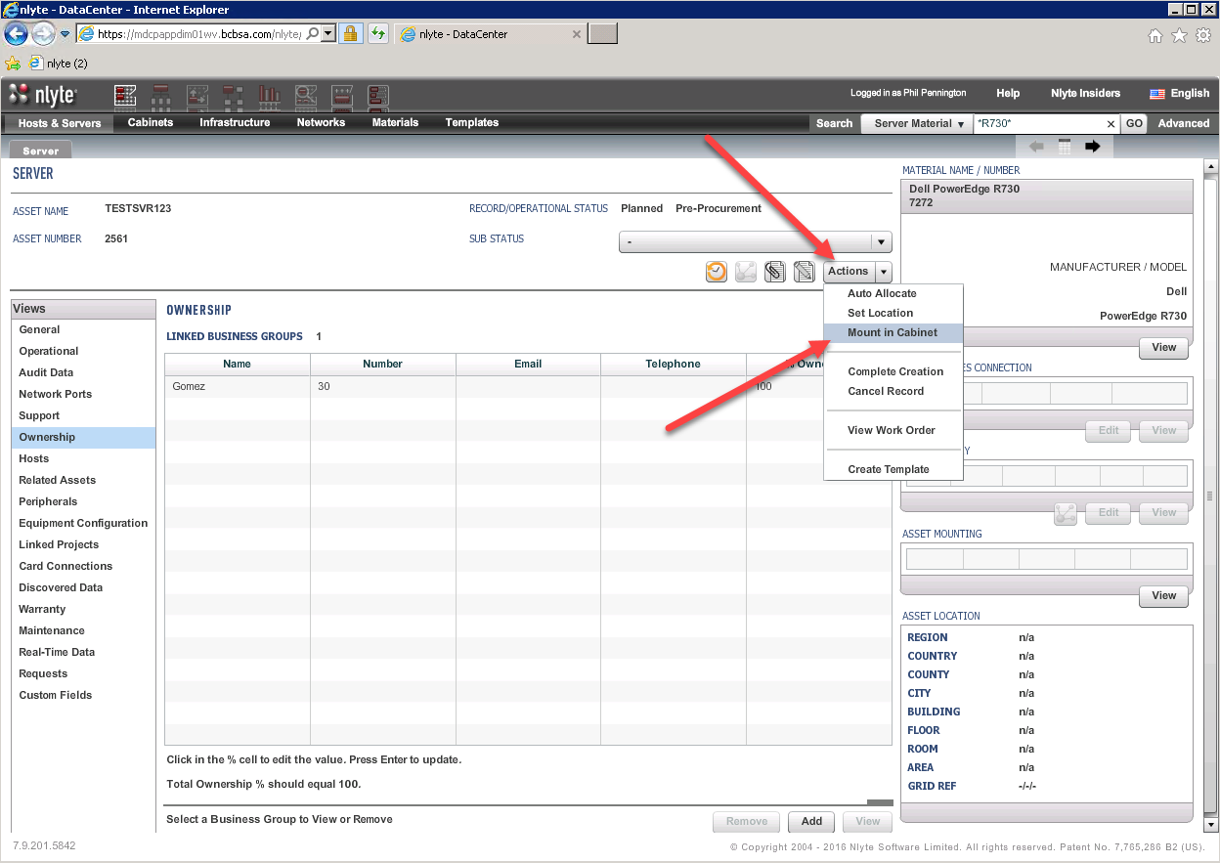

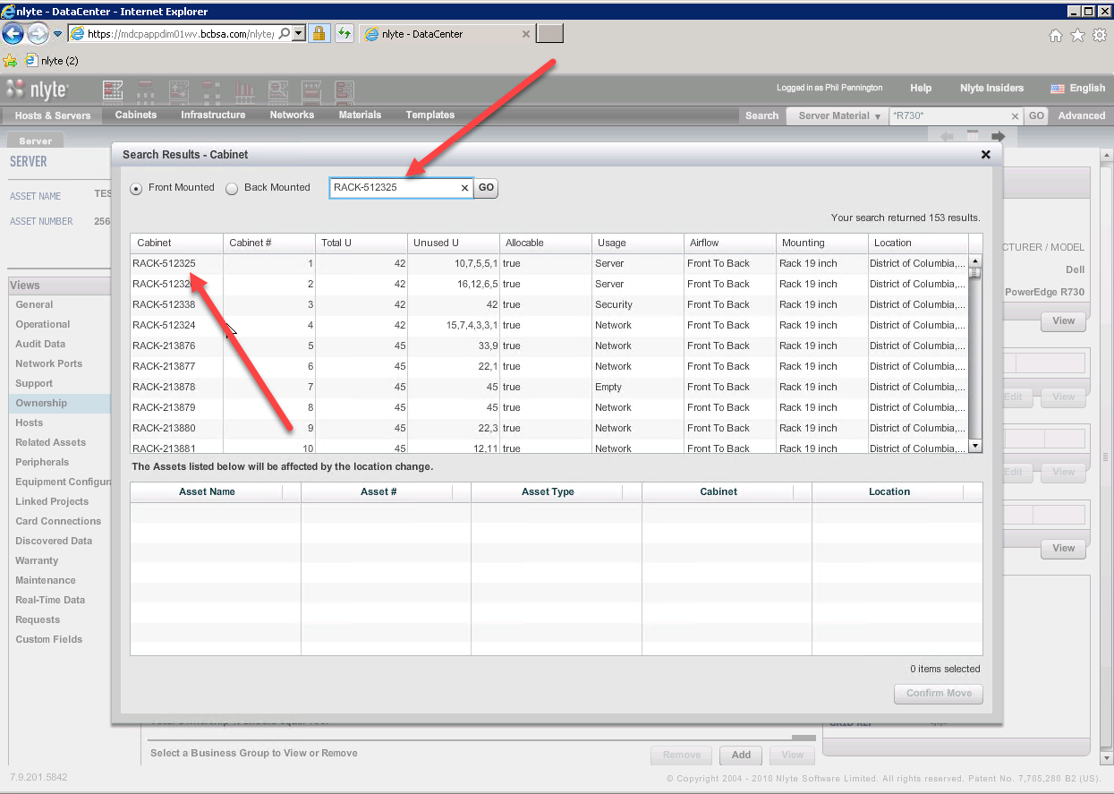

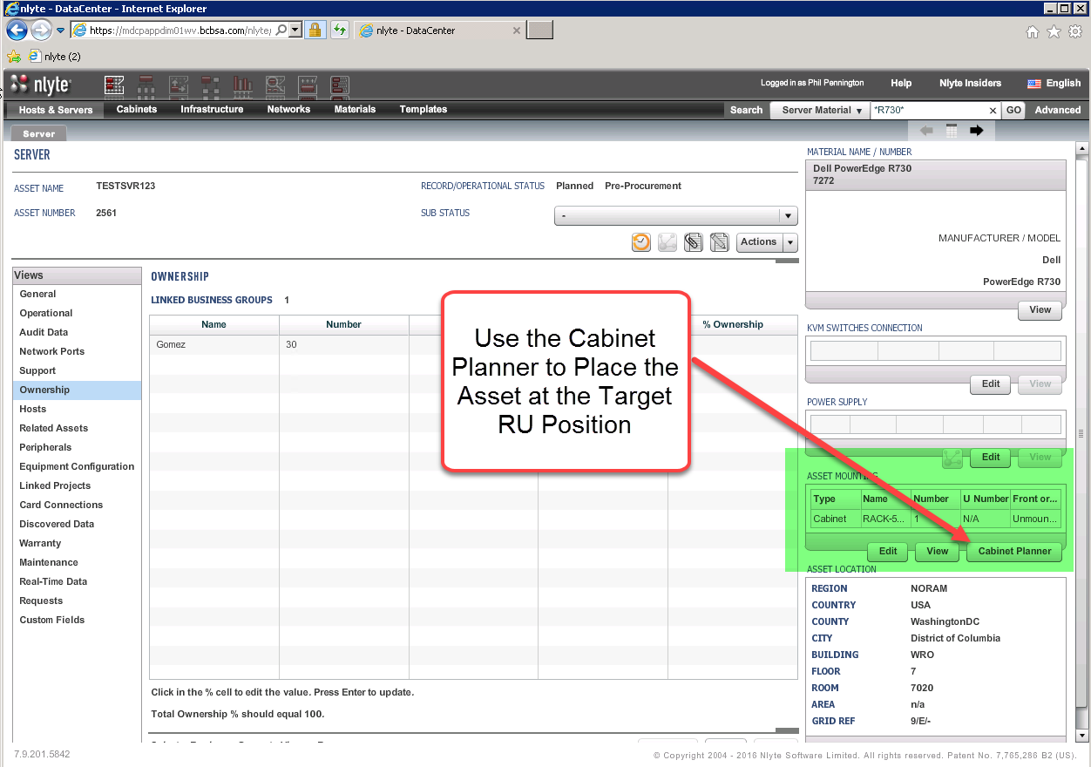

### Step 5, Place the Reserved Asset into the Target Rack Unit Position

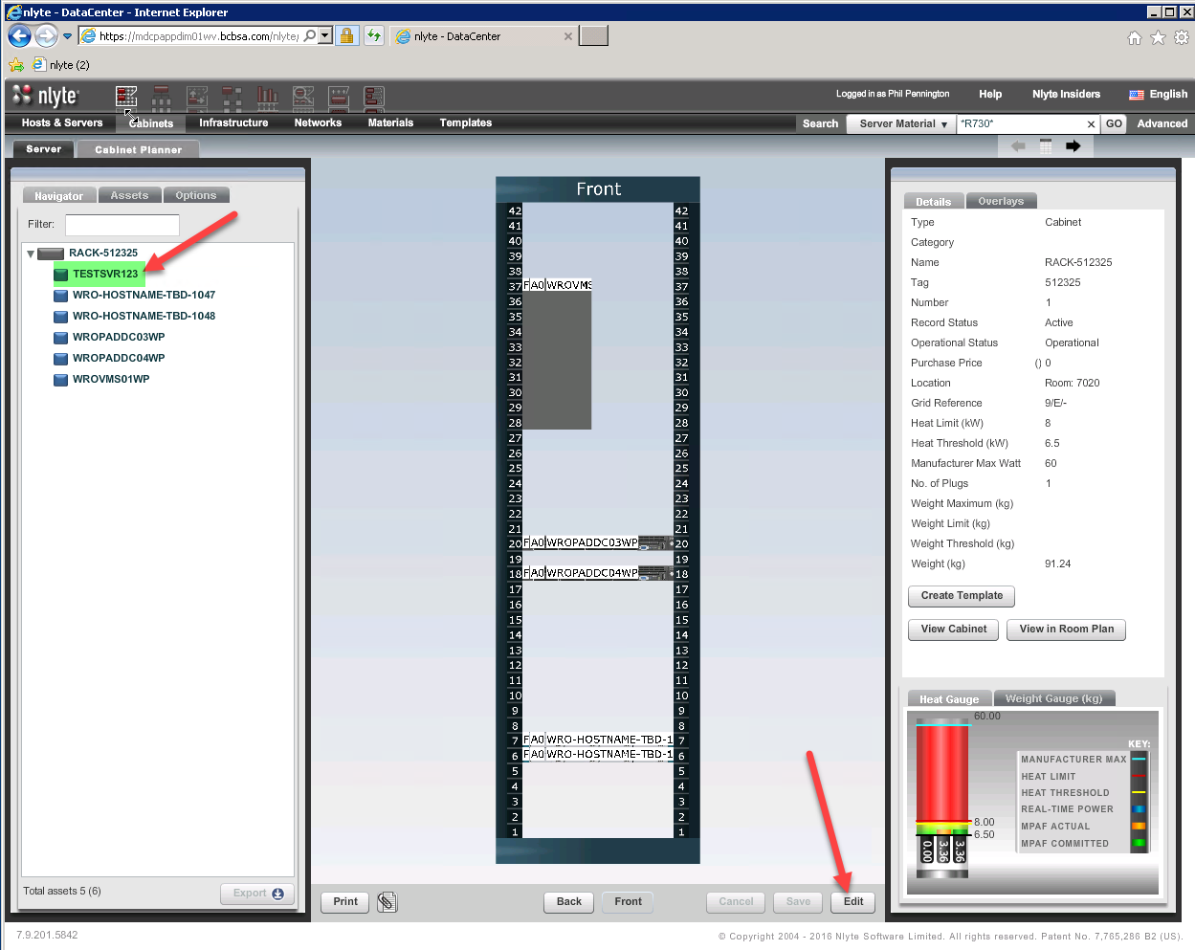

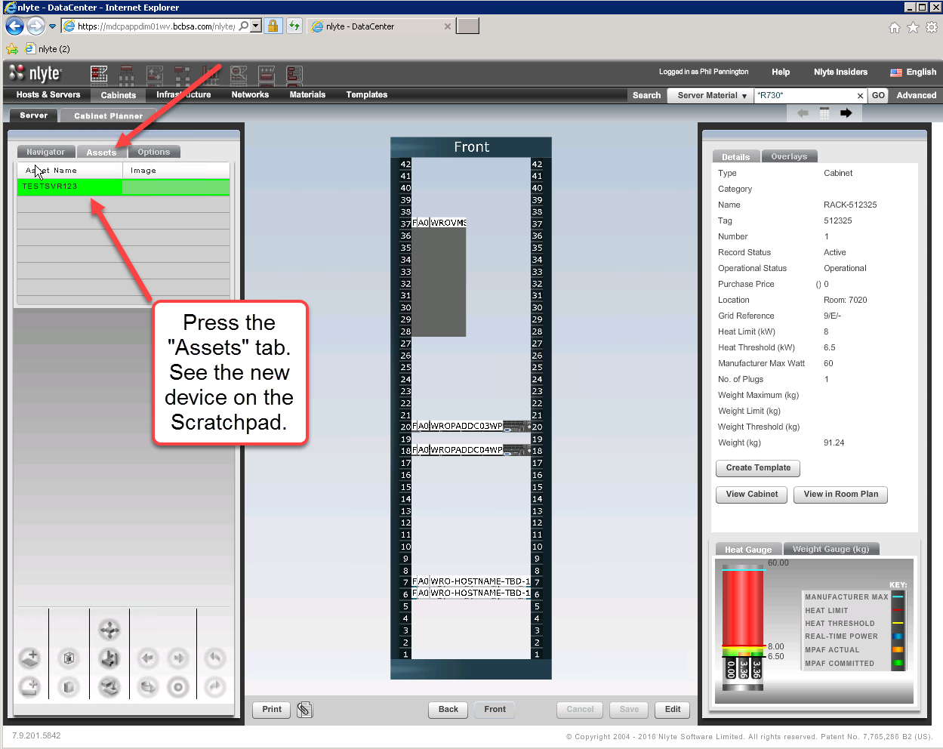

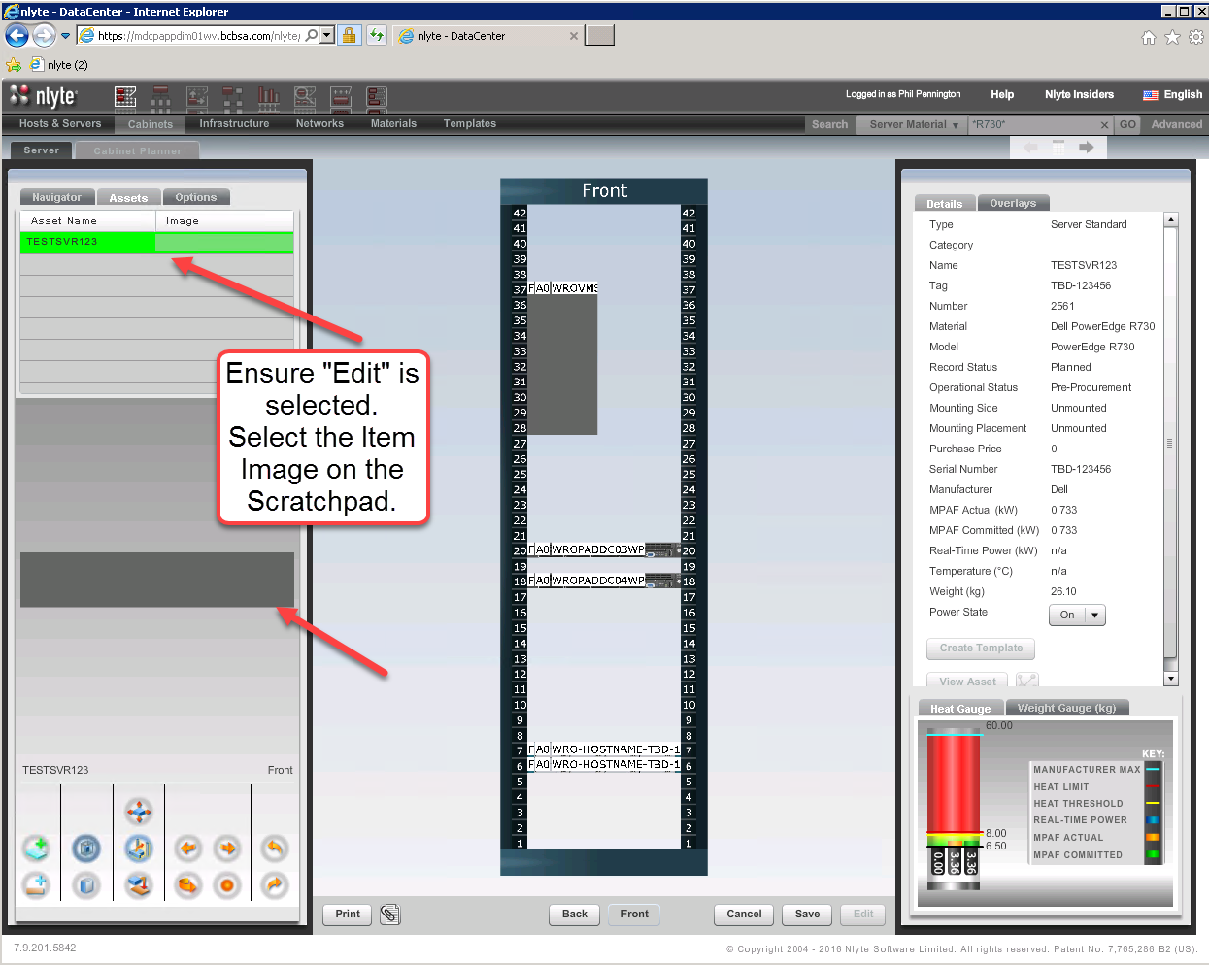

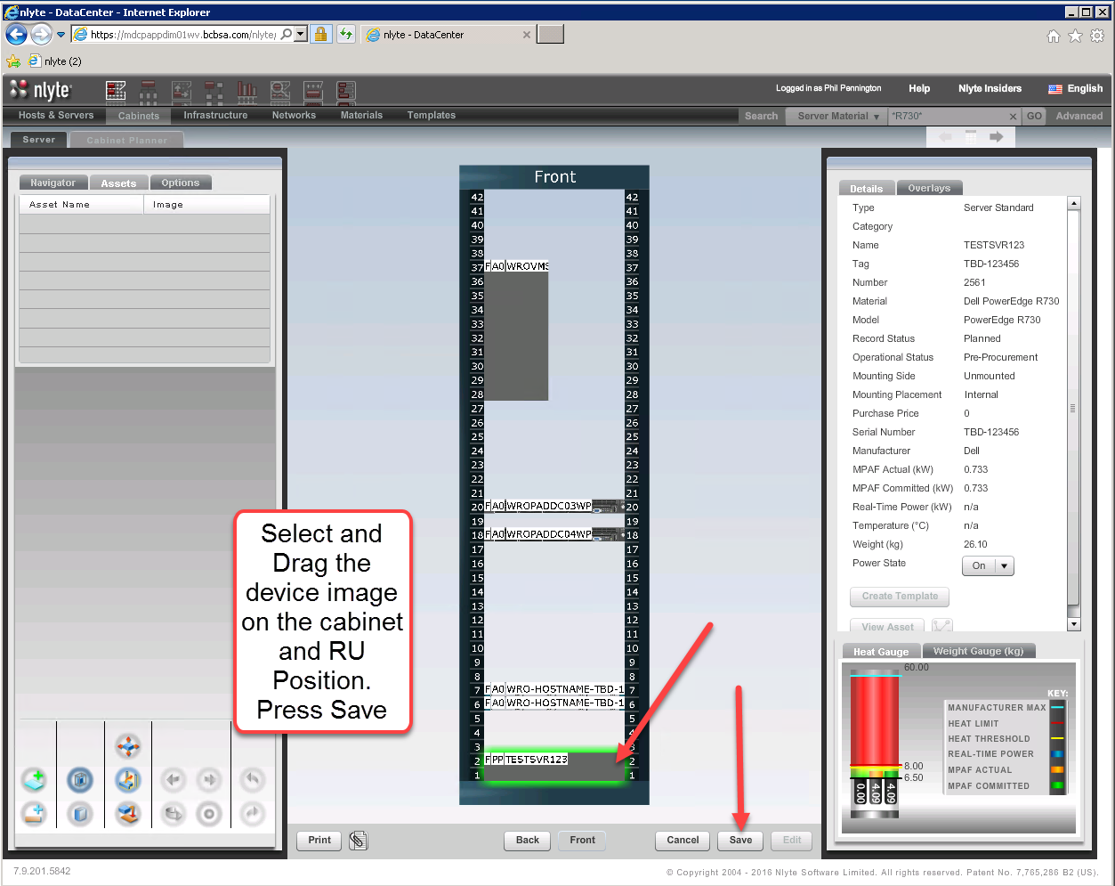

### Step 6, Update the ServiceNow Ticket with the Asset Reservation, PSC Approved Stamp

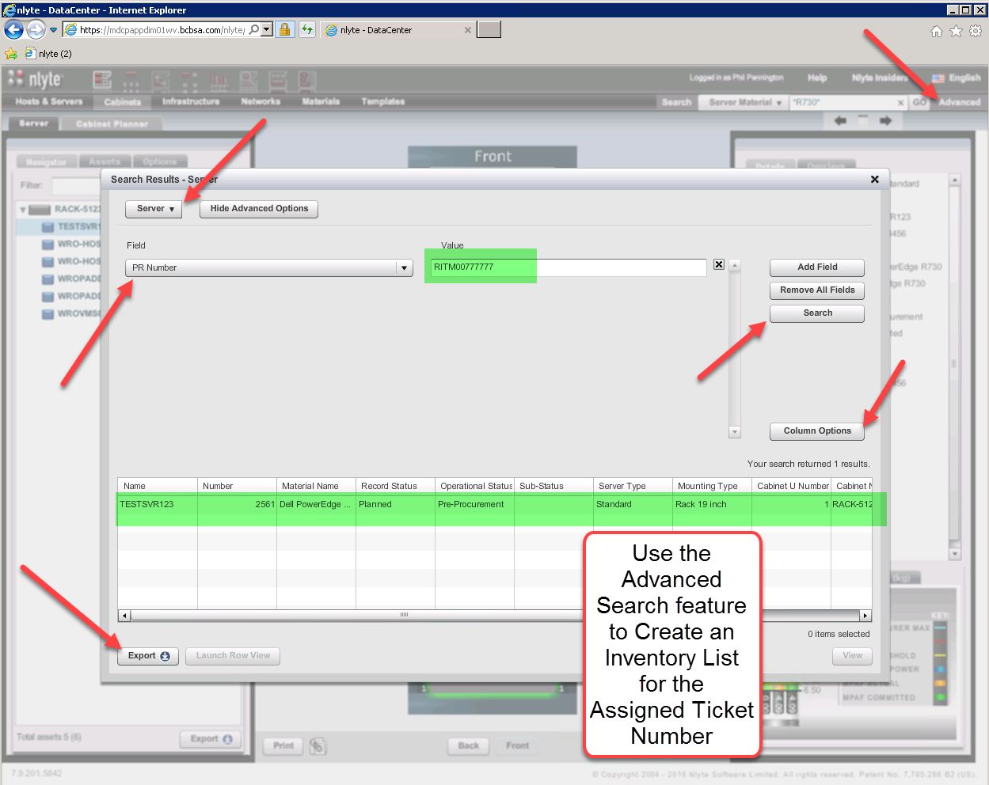

## Move Asset Request

### Move Ticket Prerequisites

The Reservations Manager should receive a Power, Space, and Cooling approval subtask within the context of any operations change request (perhaps originating from a ServiceNow workflow). The following deployment attributes are minimally required for adequate PSC evaluation.

* Requested Asset Item Inventory
* Material Catalog model identification per deployment item
* Asset RU sizes
* Tenant Cost Center
* Tenant Owner and User Names
* ServiceNow Ticket Number (i.e. NLyte PR Number)
* Cable Management details (i.e. logical and physical network topology details)
* Any non-standard cabinet mounting details (e.g. shelfs)
* Any non-standard power connectivity details.
* Asset hostnames

An approved reservation request should result in a ticket update stamp with the following minimal detail list.

* PSC Approved Statement
* Per Item Cabinet Name and Rack Unit assigned location
* Detailed approval prerequisite statements (e.g. prior asset move or decommissioning dependencies)

For example, assume the following simple PSC approval move request details:

* ServiceNow Ticket Number = RITM00888888
* Hostname = TESTSVR001
* Target Cabinet = RACK-512338
* Assumptions
  + Power and Space availability decisions for the target move location have been accomplished utilizing the NLyte feature options discussed above within the “Supporting NLyte Feature Areas” topic.

### Step 1, Locate the Existing NLyte Asset Record

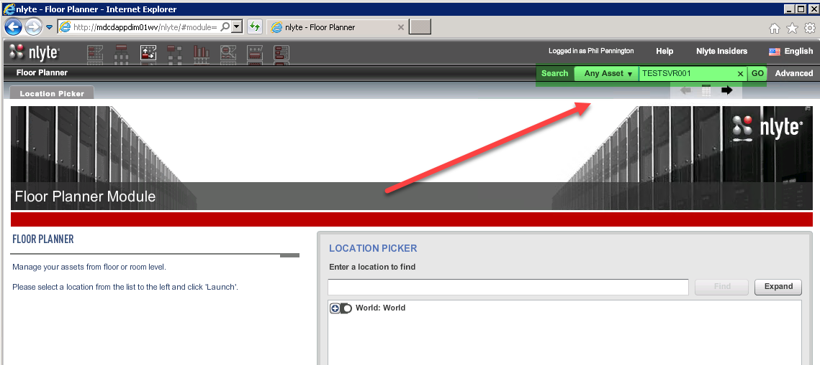

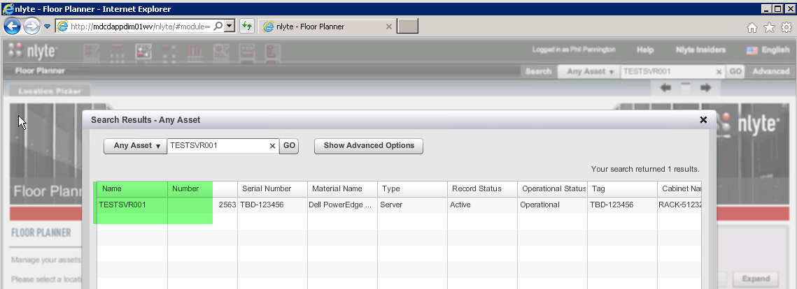

### Step 2, Record the Request Ticket Number within the PR Number field

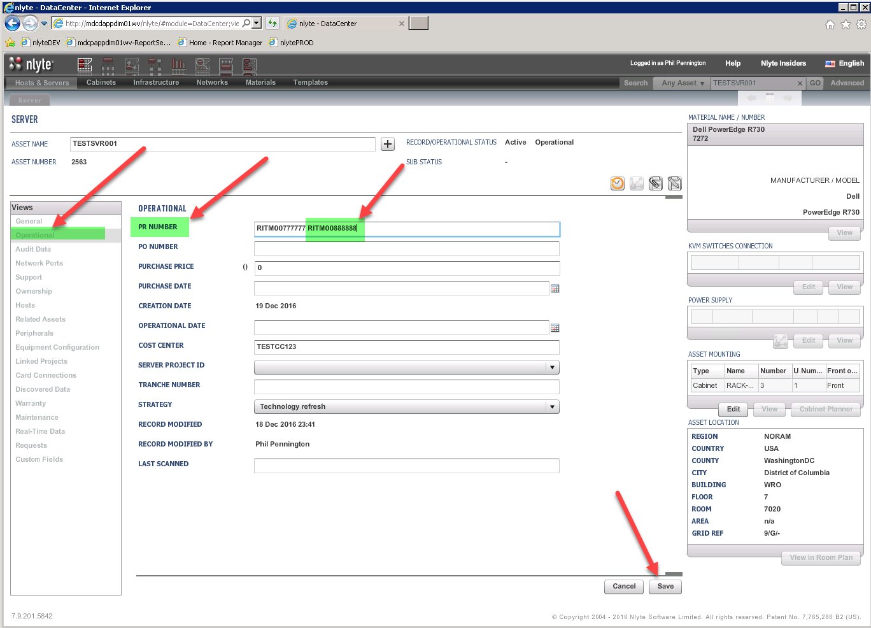

### Step 3, Place the Asset in a Planned Move State

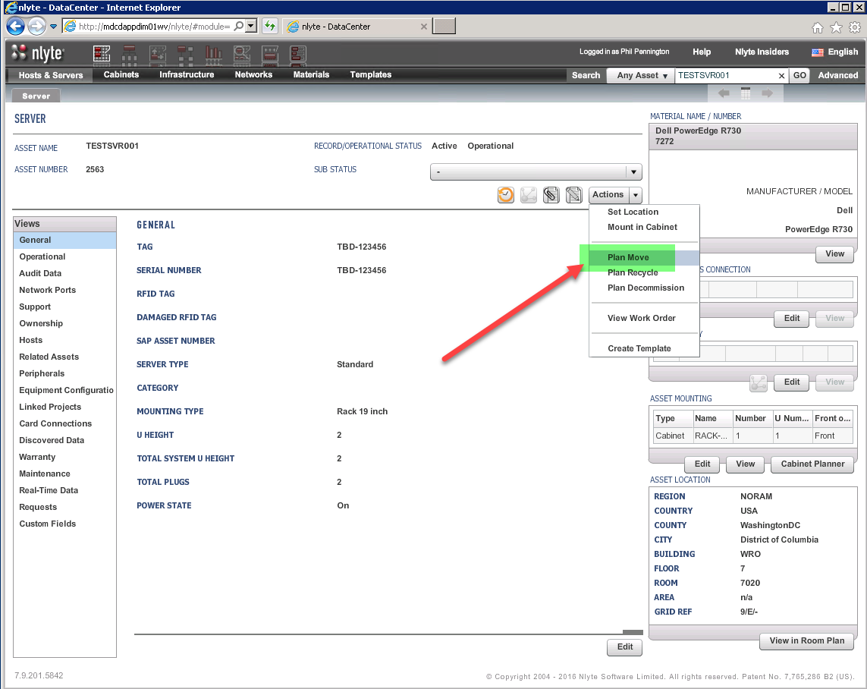

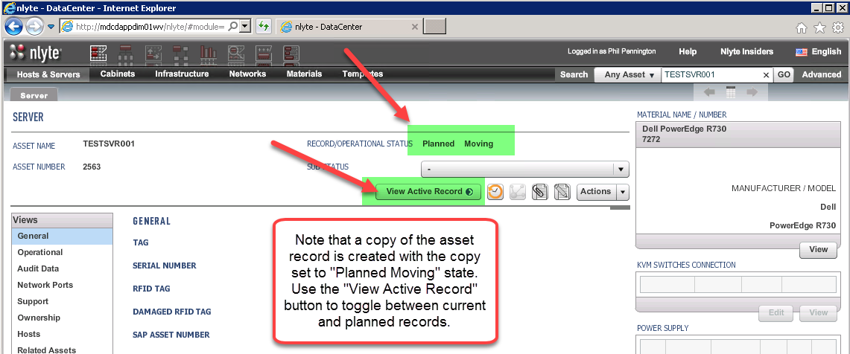

### Step 4, Mount the “Planned Moving” Asset Record into the Target Cabinet Location

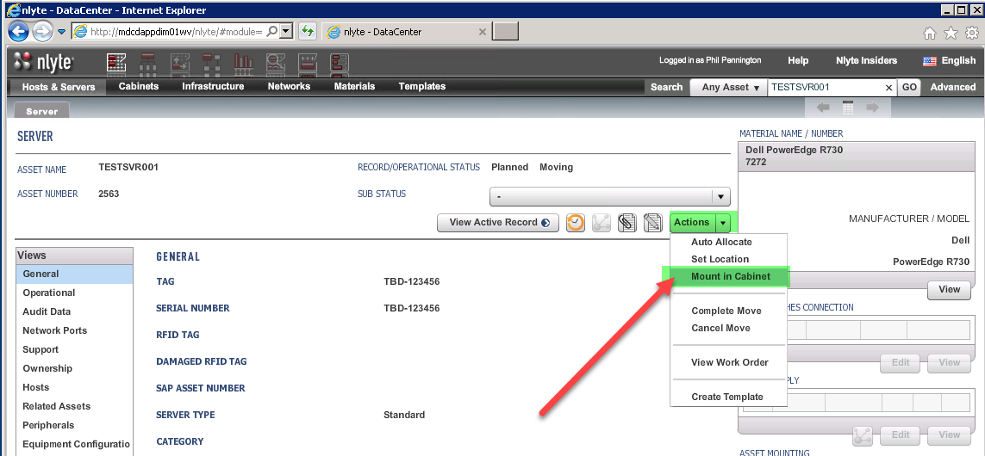

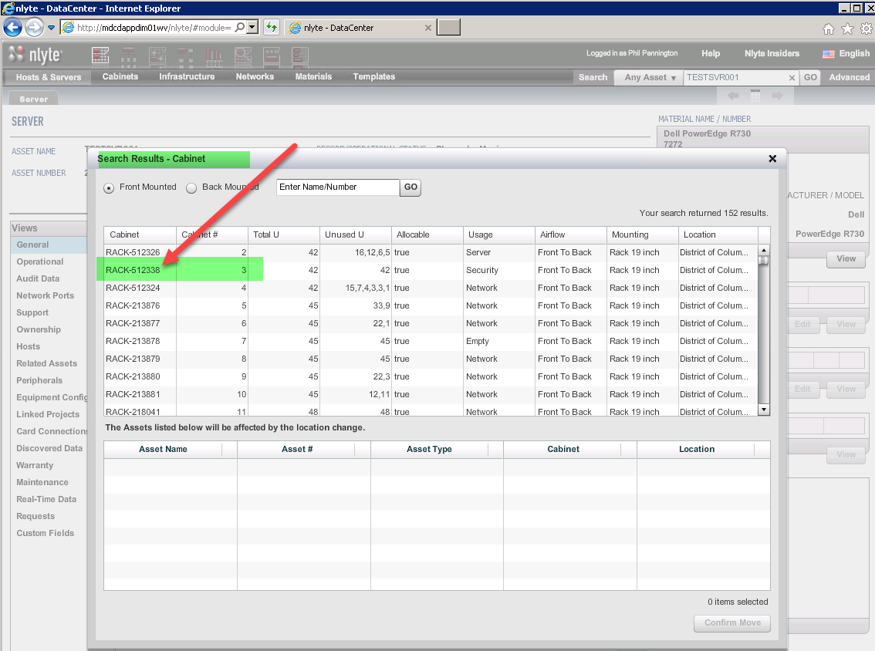

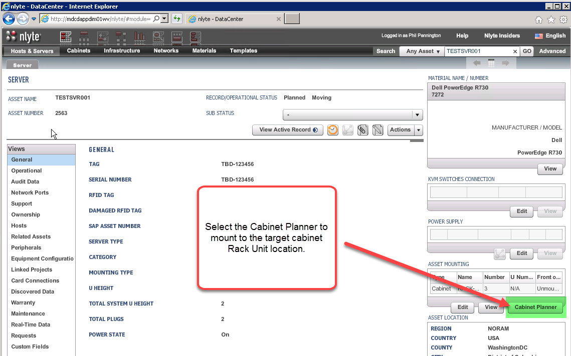

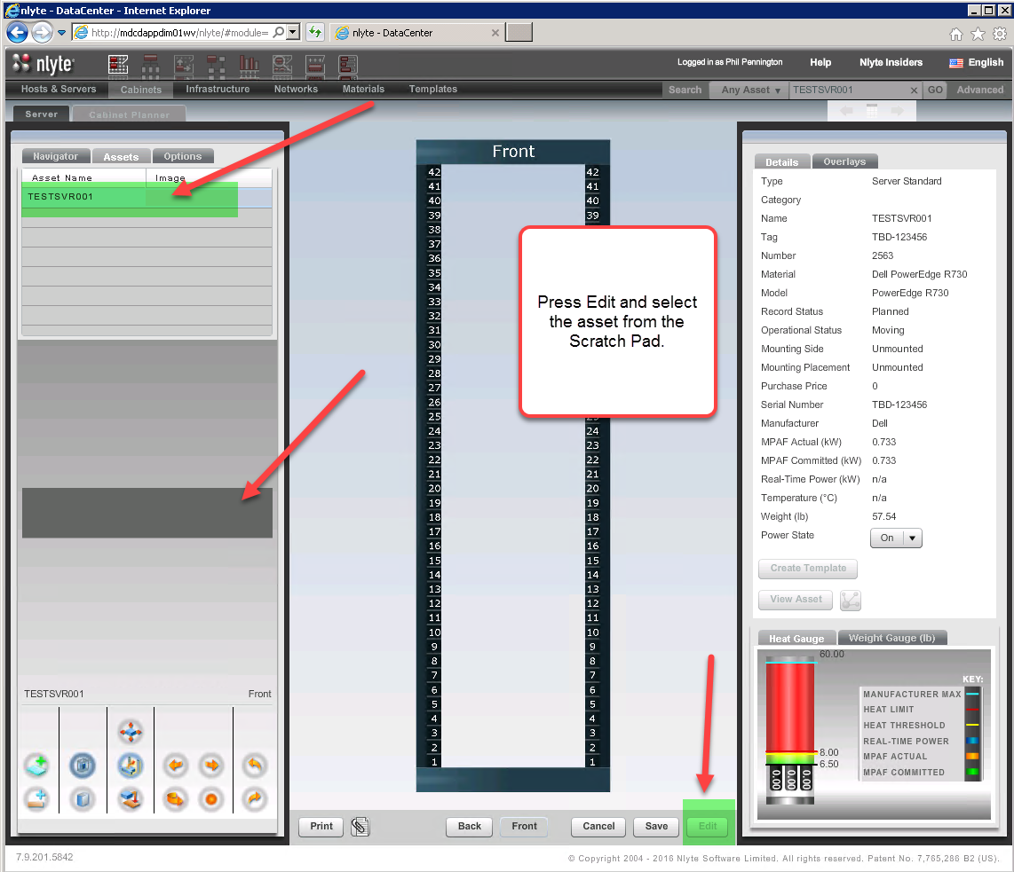

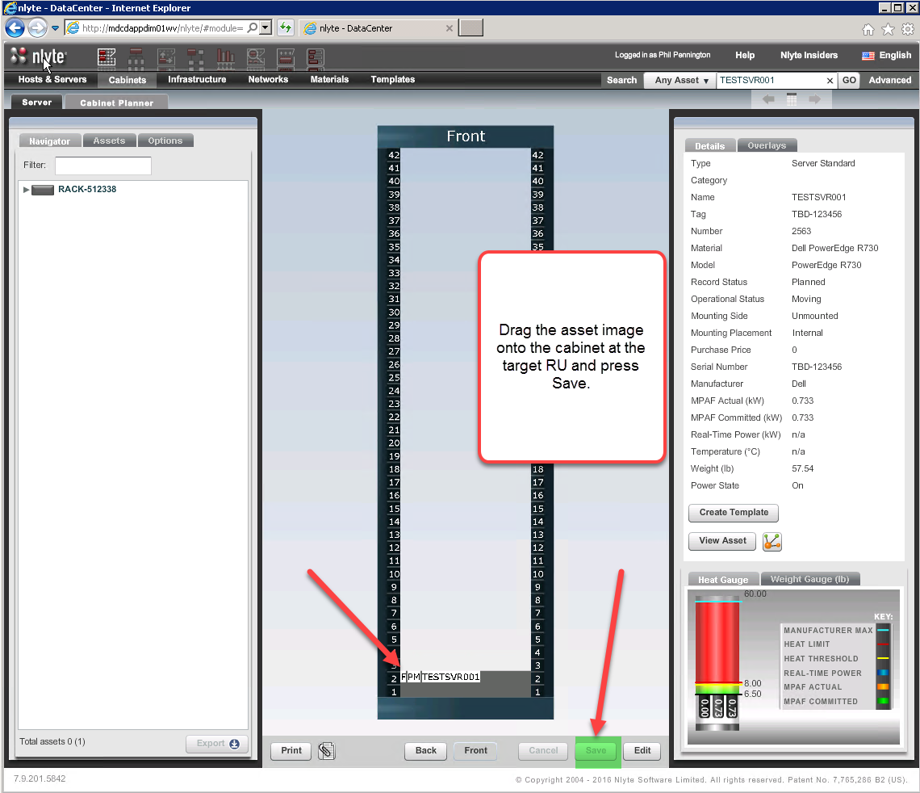

### Step 5, Forward the Work Order to the Operations Team for Fulfillment

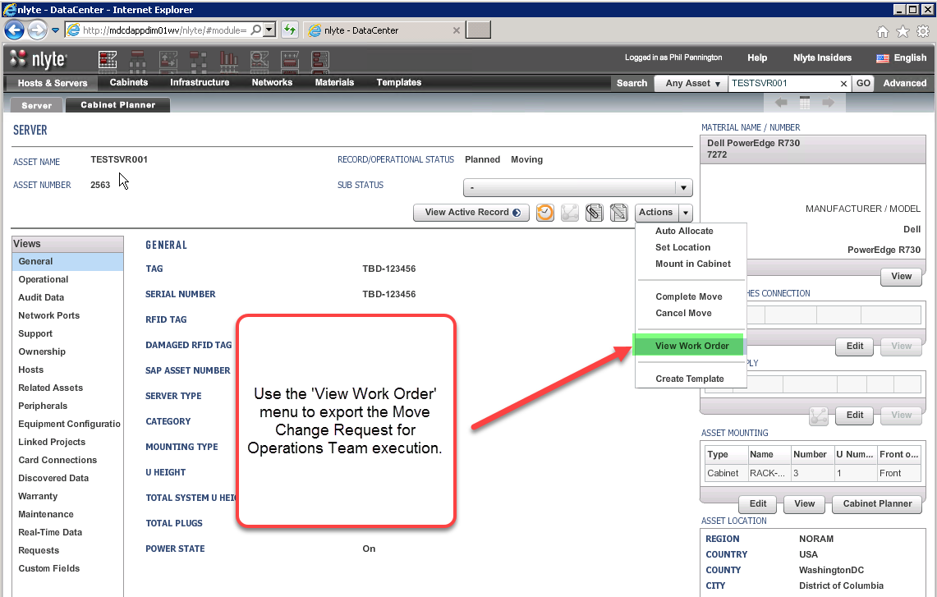

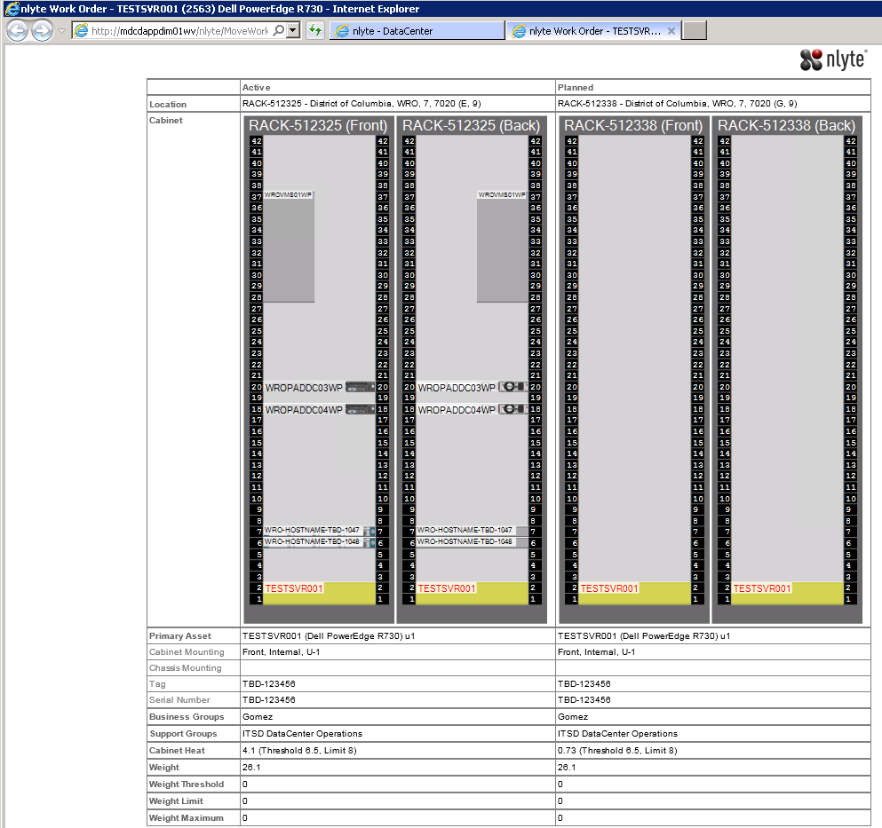

### Step 6, The Operations Team Completes the Move Request

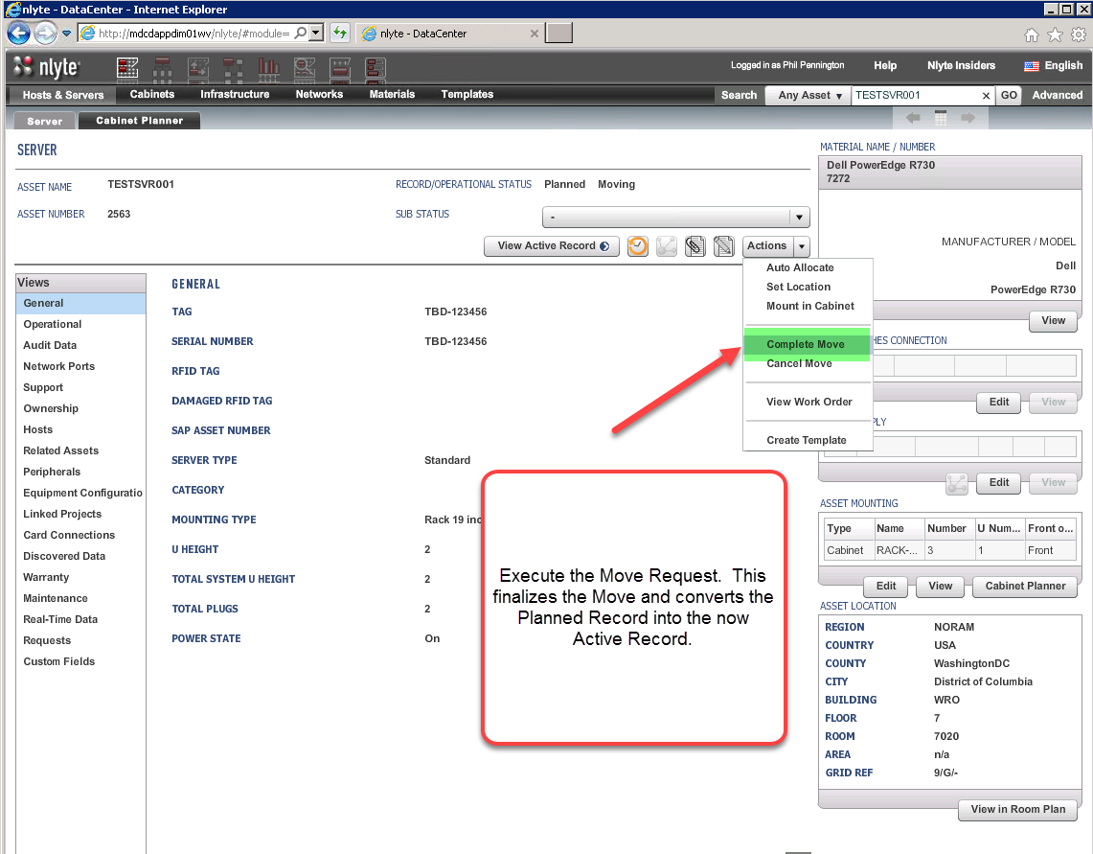

## Decommission Asset Request

### Decommission Ticket Prerequisites

The Reservations Manager should receive an approval subtask within the context of any operations change request (perhaps originating from a ServiceNow workflow).

An approved request should result in a ticket update stamp with the following minimal detail list.

* Change Approved Statement
* Per Item Cabinet Name and Rack Unit assigned location
* Detailed approval prerequisite statements (e.g. prior asset move or decommissioning dependencies)

For example, assume the following simple decom approval request details:

* ServiceNow Ticket Number = RITM00999999
* Hostname = TESTSVR001
* Assumptions
  + Logistics, Financing, and Tenant decommissioning workflow tasks have been initiated separately.

### Step 1, Locate the Existing NLyte Asset Record





### Step 2, Record the Decommissioning Ticket Number

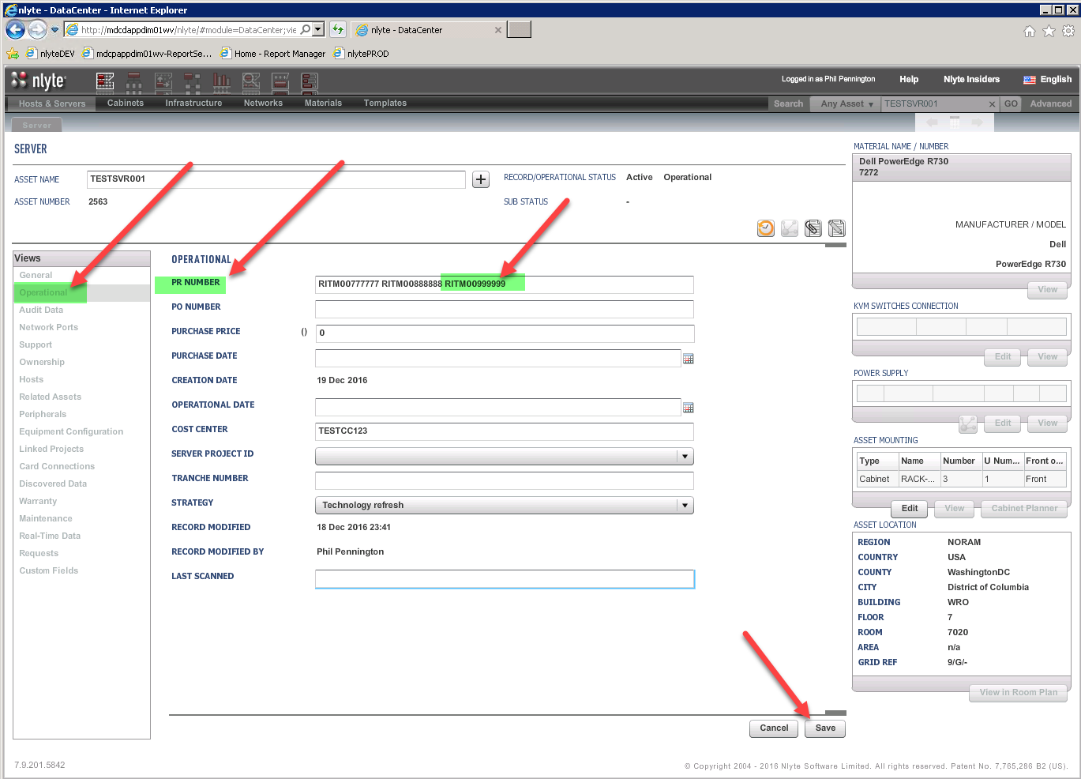

### Step 3, Place the Asset in a Planned Decommissioning State

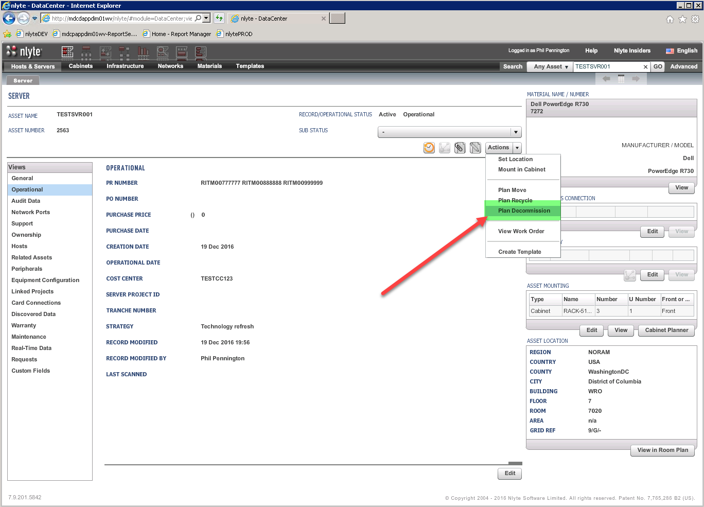

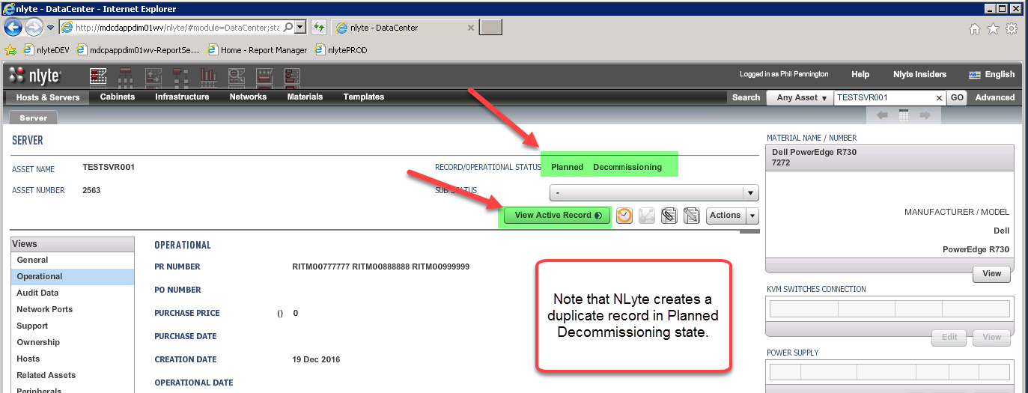

### Step 4, Set the Decommissioned Asset Location

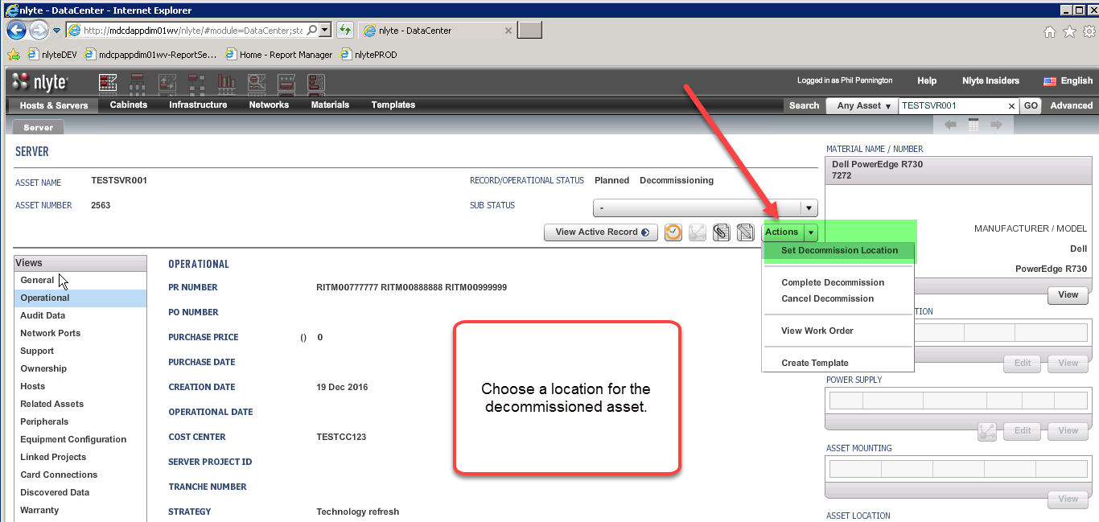

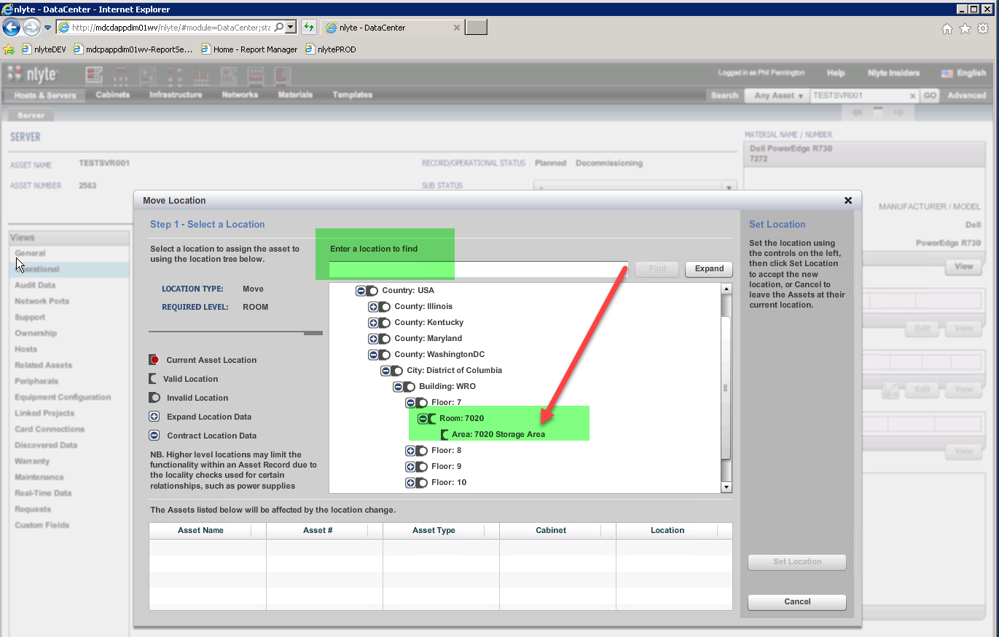

### Step 5, Forward the Work Order to the Operations Team for Fulfillment

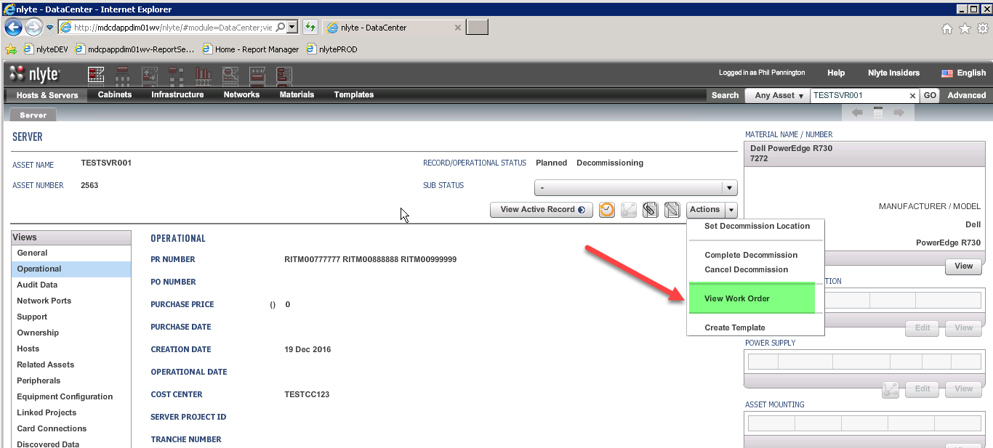

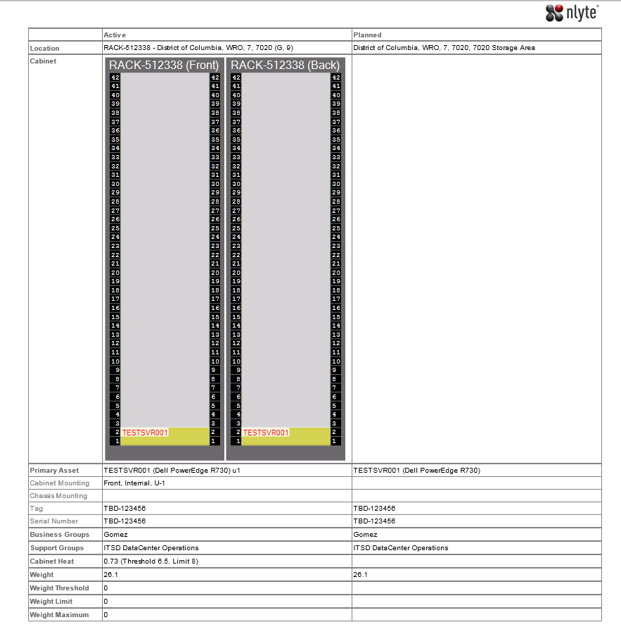

### Step 6, The Operations Team Completes the Decommission Request

